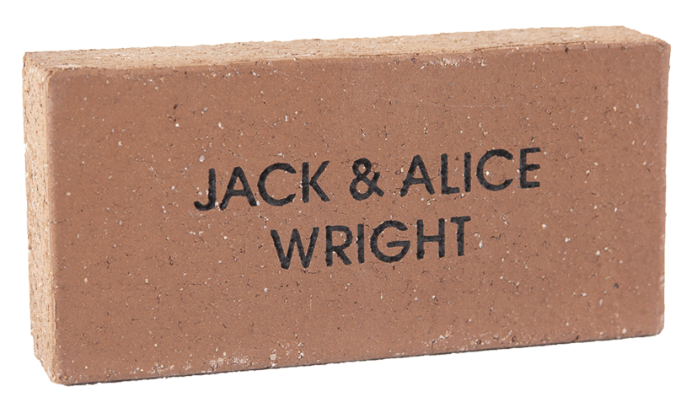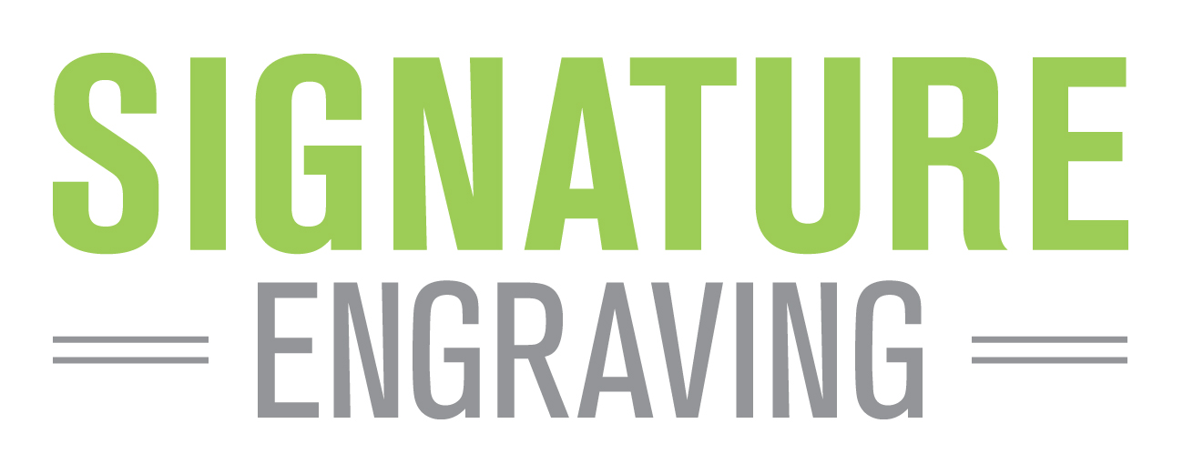

‘Buy a brick’

fundraiser

Your donation entitles you to have your name engraved into a paver as a lasting record of your valued support. The paver will be permanently installed along **Best Street Shopping Strip,** proudly showing your donation. Size: 230 x 115 x 50mm

SINGLE NAME PAVER: $40

(or $35 per paver for two or more in an order)



|  |  |  |  |  |  |  |  |  |  |  |  |  |  |  |  |  |  |  |  |  |  |  |  |  |  |  |  |  |  |  |  |
| --- | --- | --- | --- | --- | --- | --- | --- | --- | --- | --- | --- | --- | --- | --- | --- | --- | --- | --- | --- | --- | --- | --- | --- | --- | --- | --- | --- | --- | --- | --- | --- |
| **LINE 1** |  |  |  |  |  |  |  |  |  |  |  |  |  |  |  |  |  |  |  |  |  |  |  |  |  |  |  |  |  |  |  |
|  |  |  |  |  |  |  |  |  |  |  |  |  |  |  |  |  |  |  |  |  |  |  |  |  |  |  |  |  |  |  |  |
| **LINE 2** |  |  |  |  |  |  |  |  |  |  |  |  |  |  |  |  |  |  |  |  |  |  |  |  |  |  |  |  |  |  |  |
|  |  |  |  |  |  |  |  |  |  |  |  |  |  |  |  |  |  |  |  |  |  |  |  |  |  |  |  |  |  |  |  |
| **LINE 3** |  |  |  |  |  |  |  |  |  |  |  |  |  |  |  |  |  |  |  |  |  |  |  |  |  |  |  |  |  |  |  |

Simply fill out this form and return along with full payment by cash, cheque or money order to:

Or Advance Sea Lake Inc **BSB** 633 000 **A/c** 156 943 284. (Email pdamos19@gmail.com)

**Advance Sea Lake Inc**

**PO Box 190 Sea Lake**

**VIC 3533**

|  |  |  |  |  |  |  |  |
| --- | --- | --- | --- | --- | --- | --- | --- |
| Company/Contact Name | | | | | | | |
|  | | | | | | | |
| Street | | | | | | | |
|  | | | | | | | |
| City | | | | | | State | Post Code |
|  | | | | | |  |  |
| Phone | |  |  |  |  | Our Donation | |
| ( ) |  |  |  |  |  |  | |

© 2020 Signature Engraving - www.signature-engraving.com.au V:3.0

Please copy and pass on to any friends & family.

**We Need Your Support!**

Offer closes on 14 August 2020

NAME PAVER

Please print clearly in block letters (CAPITALS) and always use the ampersand symbol (“&”). Each box represents a character (letter, number, punctuation mark or space). Max 16 characters per line, three lines per paver. (No hand drawings)

ENGRAVING DETAILS (If ordering more than one paver, please use separate sheets.)

Advance Sea Lake Inc proposes to create a visual record of Sea Lake Australia Day recipients by recording their names on pavers in Apex Park. To support this project, we are inviting your participation in this fundraising venture.

Advance Sea Lake Inc