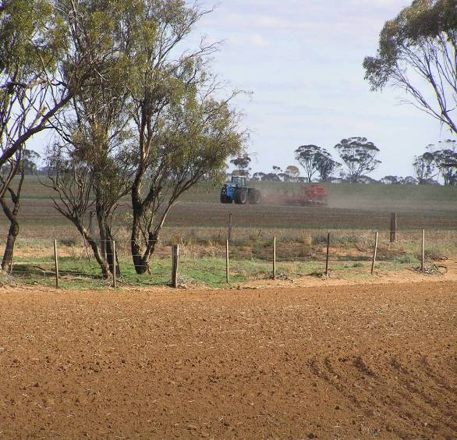
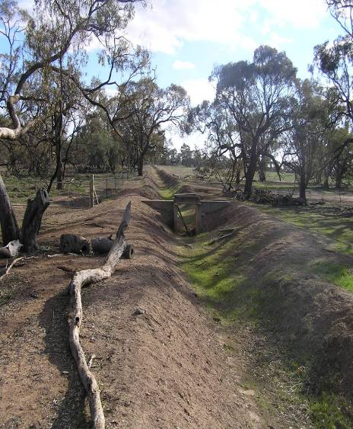
Rural Support - Key Contact Numbers
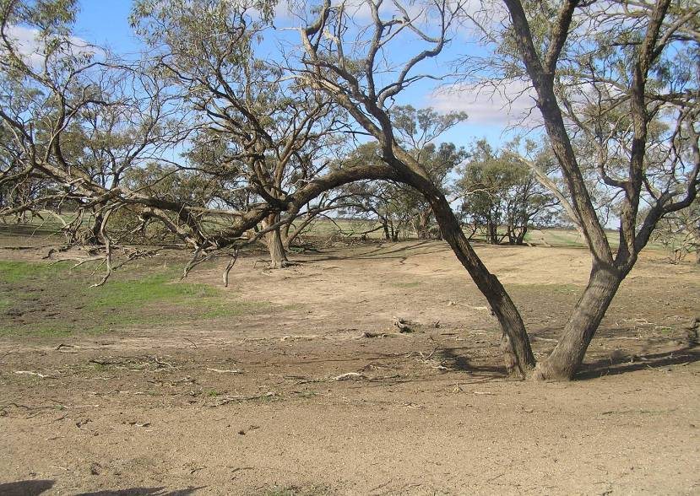
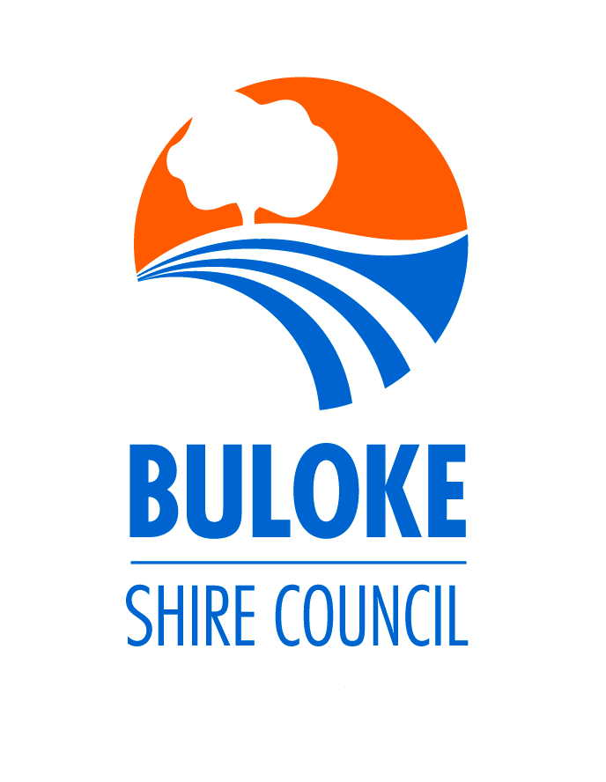
Centrelink  Exceptional Circumstances Assistance  Rural Social Workers | Drought Assistance Line  Steve Ryan (Bendigo)  Chris Marshall (Horsham)  Rik Cunningham (Swan Hill)  Carly Ridsdale (Bendigo)  Dennis Barnett (Swan Hill) | 132 316  0414 947 602  0458 398 336  0429 041 034  0414 802 917  03 5036 5641
Rural Financial Counsellors  Assessing the farm/business finances, drought options, referral to relevant services | Teresa O’Brien  John Byrne | 0409 188 724  0428 238 683
Personal Counselling  East Wimmera Health Service  Wimmera Uniting Care  Mallee Track Health Service  The Baudinet Centre,  Swan Hill  Child First | Jean Bray  Rebecca Bennett  Rural Counsellors  Grant Doxy  Elisabeth  Dennis Gel | 03 5477 2139  03 5477 2139  1800 112 177  0438 950 202  03 5032 1199  0427 702 155
Department of Primary Industries | Drought Information Line  DeAnne Price DPI Horsham | 136 186  0417 115 413
Granite Church | Coordinator  Jan Adcock | 03 5498 5225
Buloke Shire Council  Information & assistance | Mark Remnant | 0439 611 148
ALL OF THE ABOVE CONTACTS ARE FREE AND CONFIDENTIAL CONTACTS
CONTINUE REVERSE SIDE

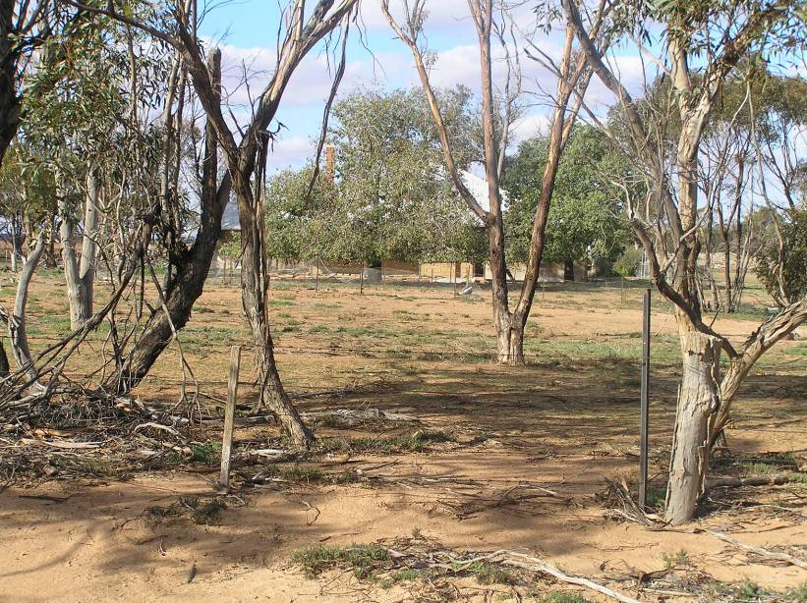
Community Resource Centres | Birchip  Simone Christie  Donald  Peter Vallance  Wycheproof  Melanie Riley  Sea Lake  Kellie Matthews | 03 5492 2735  03 5497 1707  03 5493 7455  03 5070 1448
Salvation Army | Drought Support  John Cartwright | 0438 553 829
Donald Friends and Neighbourhood Society  Donald Uniting Church | Margaret & John Russell  Food, petrol, emergency accommodation and any other assistance | 03 5497 1033  0418 508 185
Sea Lake Welfare Group | Faye Pearce  Emergency assistance, food vouchers, fuel vouchers | 03 5070 1453
St Vincent de Paul | Birchip  Chris Hogan  Charlton  Donald  Jack Burke | 03 5492 2773  0428 586 056  03 5491 5267  03 5497 1472

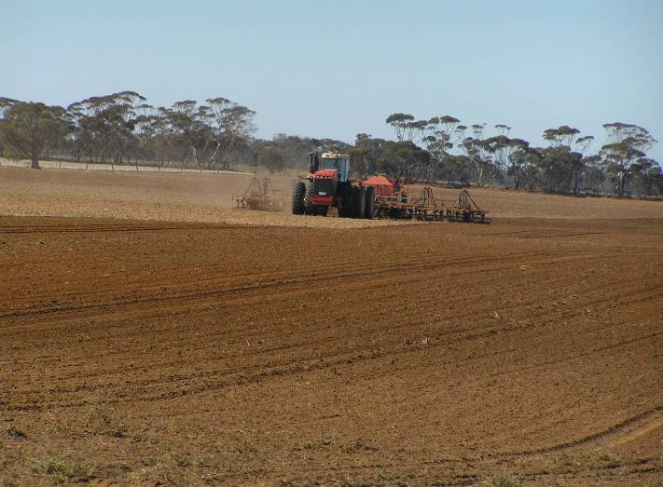
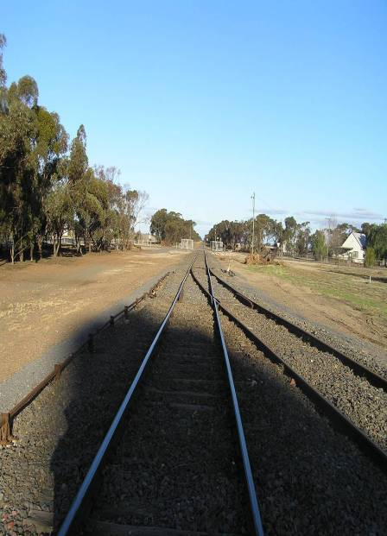

ALL OF THE ABOVE CONTACTS ARE FREE AND CONFIDENTIAL

