A0043936T
ABN: 42 456 711 915
PO Box 190
SEA LAKE 3533
advance@sealake.vic.au

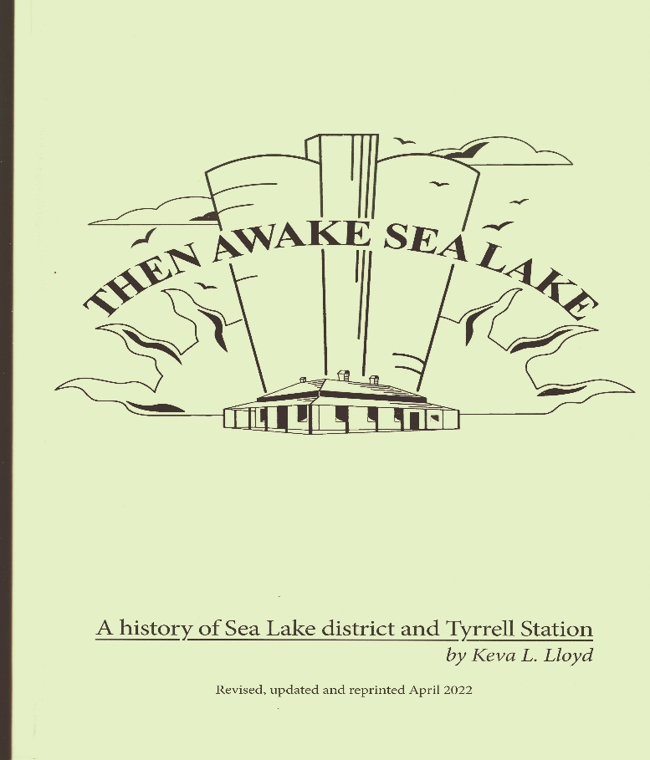
Advance Sea Lake Inc is delighted to announce that Keva Lloyd’s popular and informative history of the Sea Lake district and Tyrrell Station has recently been updated and is now available for purchase.
Originally published for the celebration, held during Easter 1997, of the Centenary of the Gazetting of Sea Lake and the Sesquicentenary of the Taking Up of Tyrrell Station, Then Awake Sea Lake has been both revised and updated for the events of the last 25 years. Colour photographs have been included in the last chapter.
Advance Sea Lake Inc would like to congratulate both Keva and Mallee Printers for their outstanding work in making this updated publication possible.
Copies can be ordered by posting or emailing this order form to the above address. Local pickup can be arranged or copies posted to your address (see below). Postage outside Australia can also be arranged, cost to be advised at time of order.
Payment can be made via the banking details below, by cheque made payable to Advance Sea Lake Inc, or at the time of collection.
Name:
Postal Address:
 | Phone: | Email:
Number of Copies @ $50 per copy | Number: | $
Postage and Handling (1-3 copies) $17 |  | $
TOTAL |  | $
Banking Details:
Advance Sea Lake Inc
BSB: 633 000
A/c: 156 943 284
Please include your name in the reference

